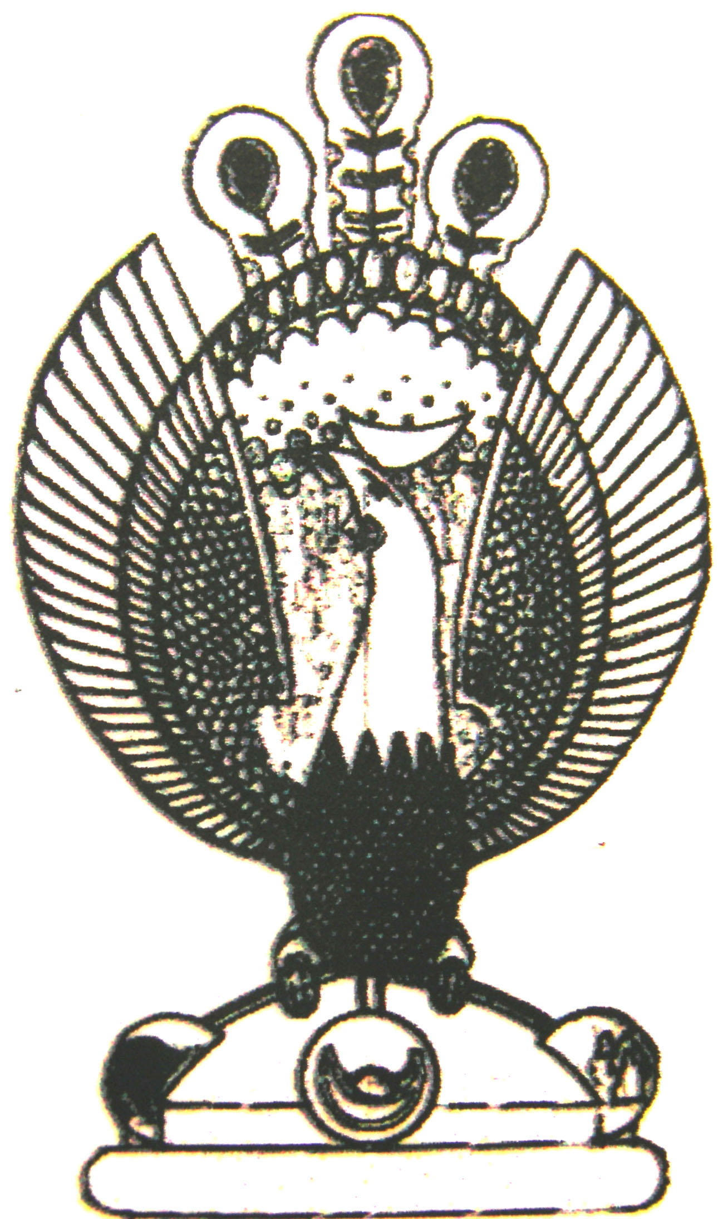

THE HERITAGE

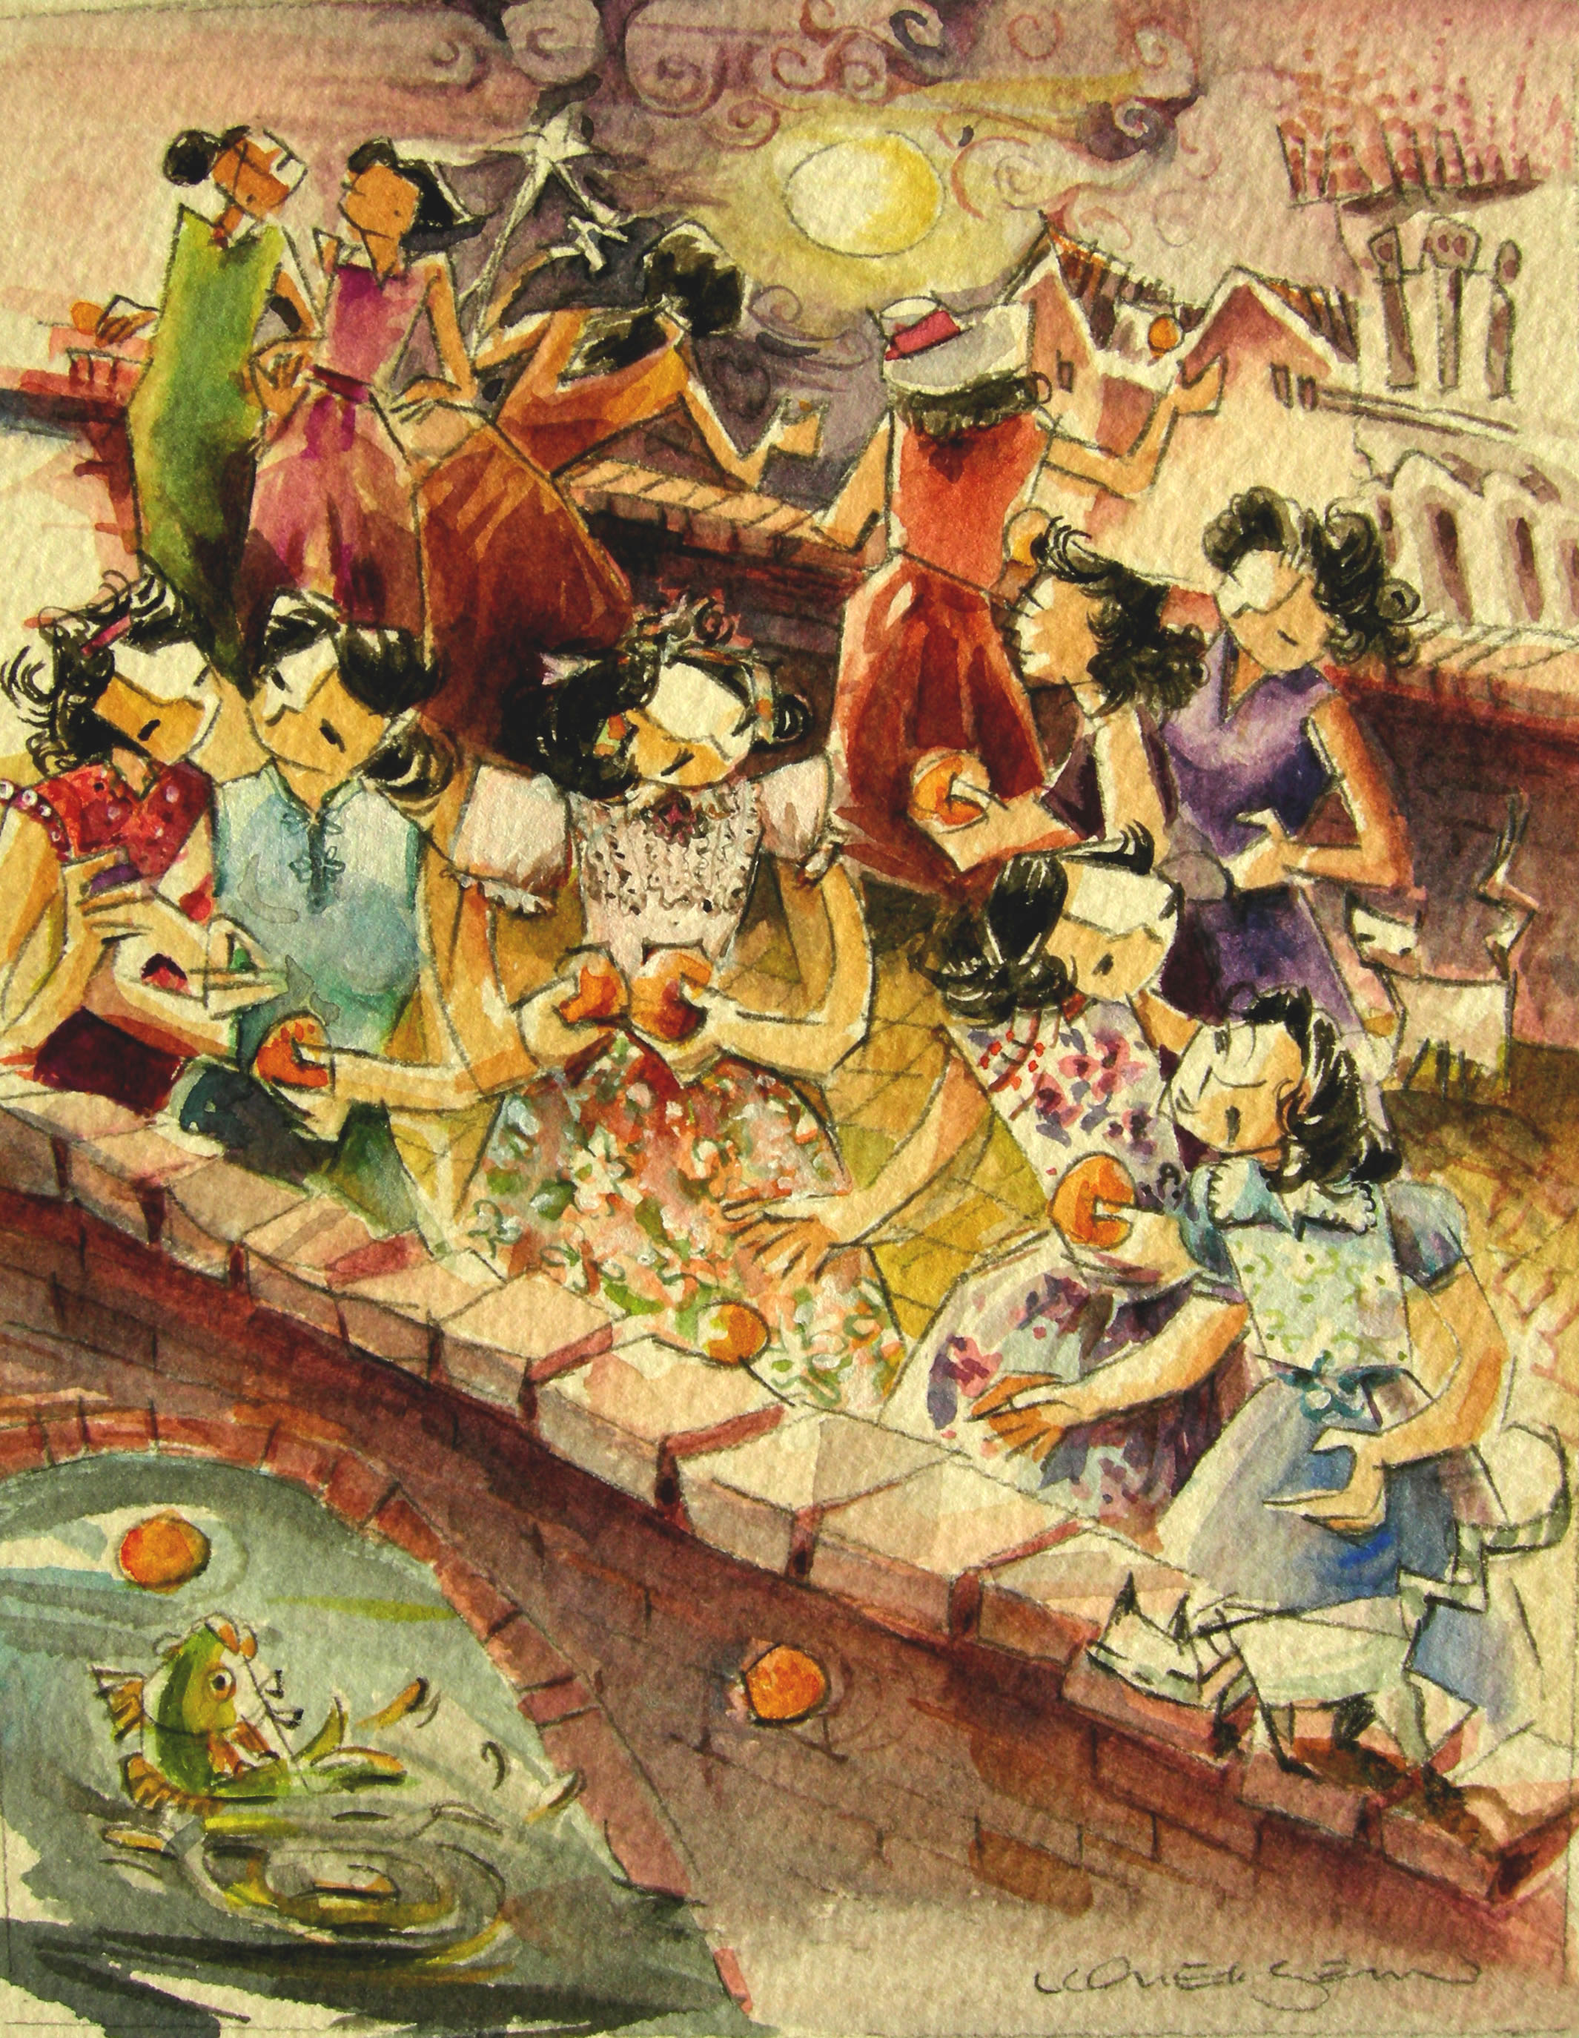
Chap Goh Meh – Orange Wish
The 15th day of Chinese New Year, Peranakan Girls would wish for a good husband and throw oranges into the river. From 7pm to midnight the girls would cross seven bridges which symbolized their different stages of life.

